**University of Michigan – Dearborn**

**CIS 200 – Computer Science II**

**Project 1 -Solo Project - myString**

**Professor Robert Mann**

Demetrius Johnson

[meech@umich.edu](mailto:meech@umich.edu)

November 02, 2020

**Table Content**

Contents

myString Program 3

# myString Program

// Project 1 F-20 - CIS 200

I ran out of time, so I did it a smarter/more efficient way. If you follow the comments from main, they directly correspond (and with labeling so you can easily locate) to the test images here in this document. For example, you will see //TEST1 in main and you will see it in the output image that it is showing the corresponding test (or sometimes multiple tests, but every single test is labeled). I know I may get marked down, but I did my best to make it super neat and easy to grade, and easy to run my main/to see/test my functions. But the screenshots and test labeling should be plenty easy enough to follow/grade.

Worked harder on this than I ever did on a project. I hope you will see the sweat and authentic hard work and knowledge it took to do this. I tried to write the code extremely efficiently, and whenever I write code I try to make it useable and understandle for the future, for myself and anyone who tries to use my code. I also do extreme commenting so every detail of my code can be followed and understood.

This 100% my work, all pure hard work. And I wasn’t able to finish the test with the file, but everything else is done to its utter completeness.

Thank you,

Meech

|  |  |  |  |  |  |  |
| --- | --- | --- | --- | --- | --- | --- |
| Test # | Valid / Invalid Data | Description of test | Input Value | Expected Output | Actual Output | Test Pass / Fail |
| 1 | VALID | See comments in mainCPP | See mainCPP |  | See screenshot | pass |
| 2 | VALID | See comments in mainCPP | See mainCPP |  | See screenshot | pass |
| 3 | VALID | See comments in mainCPP | See mainCPP |  | See screenshot | pass |
| 4 | VALID | See comments in mainCPP | See mainCPP |  | See screenshot | pass |
| 5 | VALID | See comments in mainCPP | See mainCPP |  | See screenshot | pass |
| 6 | VALID | See comments in mainCPP | See mainCPP |  | See screenshot | pass |
| 7 | VALID | See comments in mainCPP | See mainCPP |  | See screenshot | pass |
| 8 | VALID | See comments in mainCPP | See mainCPP |  | See screenshot | pass |
| 9 | VALID | See comments in mainCPP | See mainCPP |  | See screenshot | pass |
| 10 | VALID | See comments in mainCPP | See mainCPP |  | See screenshot | pass |
| 11 | VALID | See comments in mainCPP | See mainCPP |  | See screenshot | pass |
| 12 | VALID | See comments in mainCPP | See mainCPP |  | See screenshot | pass |
| 13 | VALID | See comments in mainCPP | See mainCPP |  | See screenshot | pass |
| 14 | VALID | See comments in mainCPP | See mainCPP |  | See screenshot | pass |
| 15 | VALID | See comments in mainCPP | See mainCPP |  | See screenshot | pass |
| 16 | VALID | See comments in mainCPP | See mainCPP |  | See screenshot | pass |
| 17 | VALID | See comments in mainCPP | See mainCPP |  | See screenshot | pass |
| 18 | VALID | See comments in mainCPP | See mainCPP |  | See screenshot | pass |
| 19 | VALID | See comments in mainCPP | See mainCPP |  | See screenshot | pass |
| 20 | VALID | See comments in mainCPP | See mainCPP |  | See screenshot | pass |

Test 1

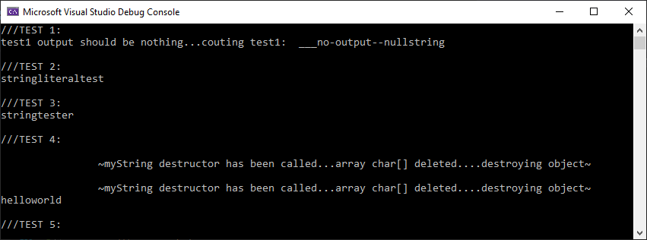

Test 2



Test 3



Test 4

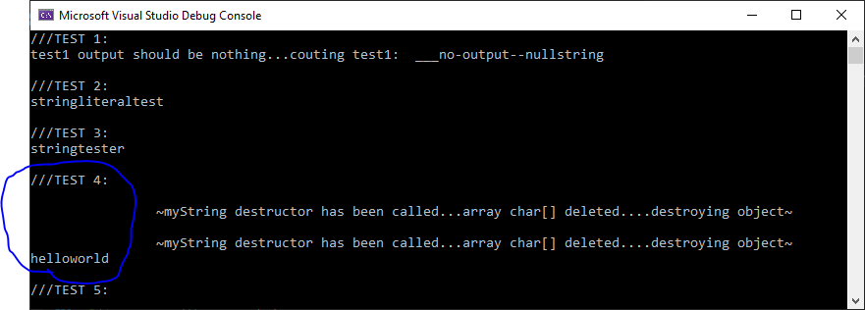

Test 5

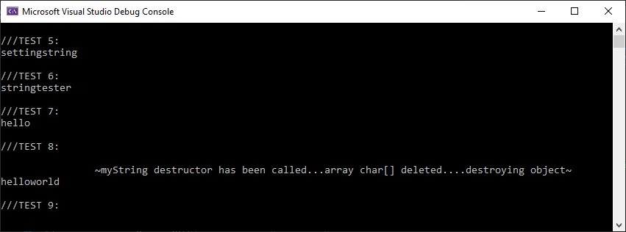

Test 6



Test 7



Test 8

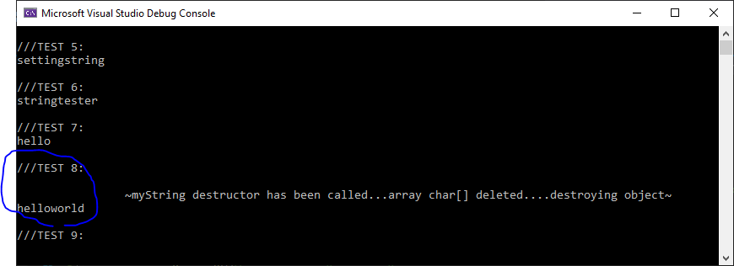

Test 9

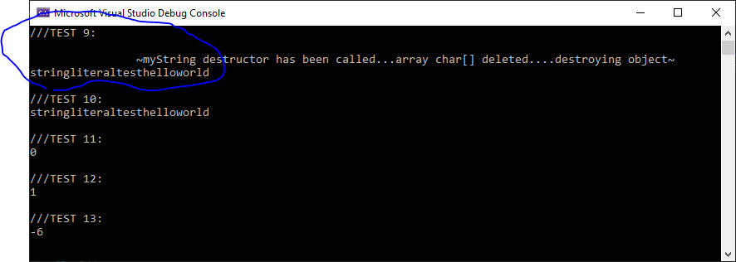

Test 10

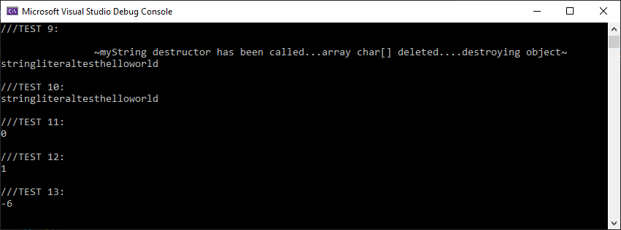

Test 11



Test 12



Test 13



Test 14

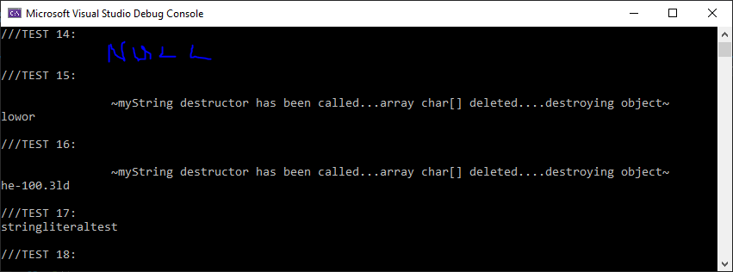

Test 15

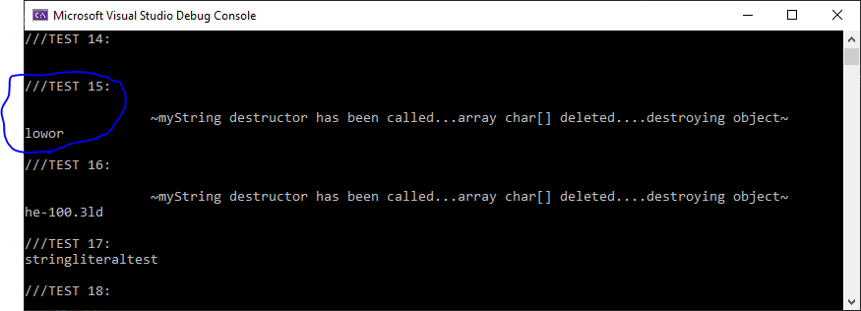

Test 16

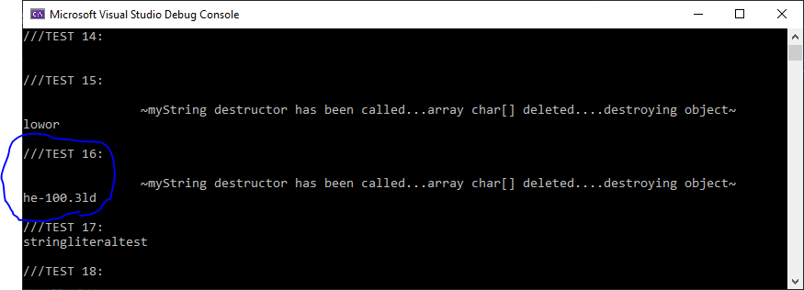

Test 17

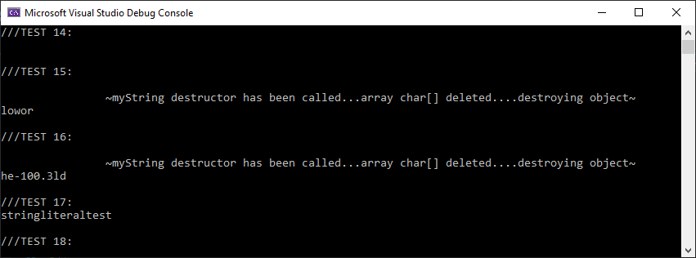

Test 18

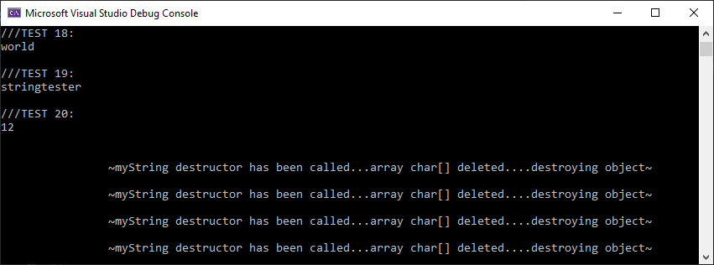

Test 19



Test 20

